**TASK REPORT**

**WEEK PROGRAMING**

**WEEK 4**

**Created by:**

**Cesario Hafidh Arifa Noorcholish**

**L200224217**

**X**

**INFORMATICS ENGINEERING**

**FACULTY OF COMMUNICATION AND INFORMATICS**

**UNIVERSITAS MUHAMMADIYAH SURAKARTA**

**2023/2024**

**TASK**

1. **Experiment 1 (Create Database)**

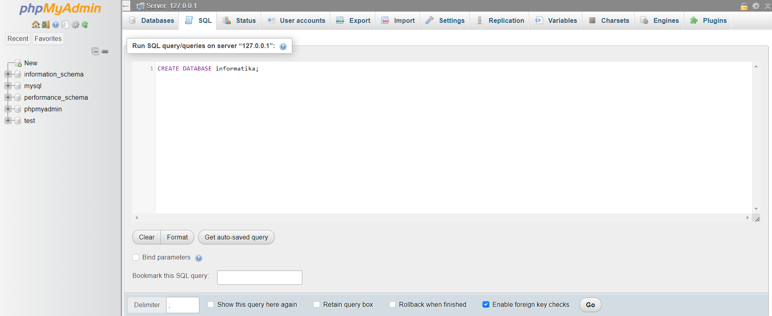

1. **Experiment 2 (Create Table)**

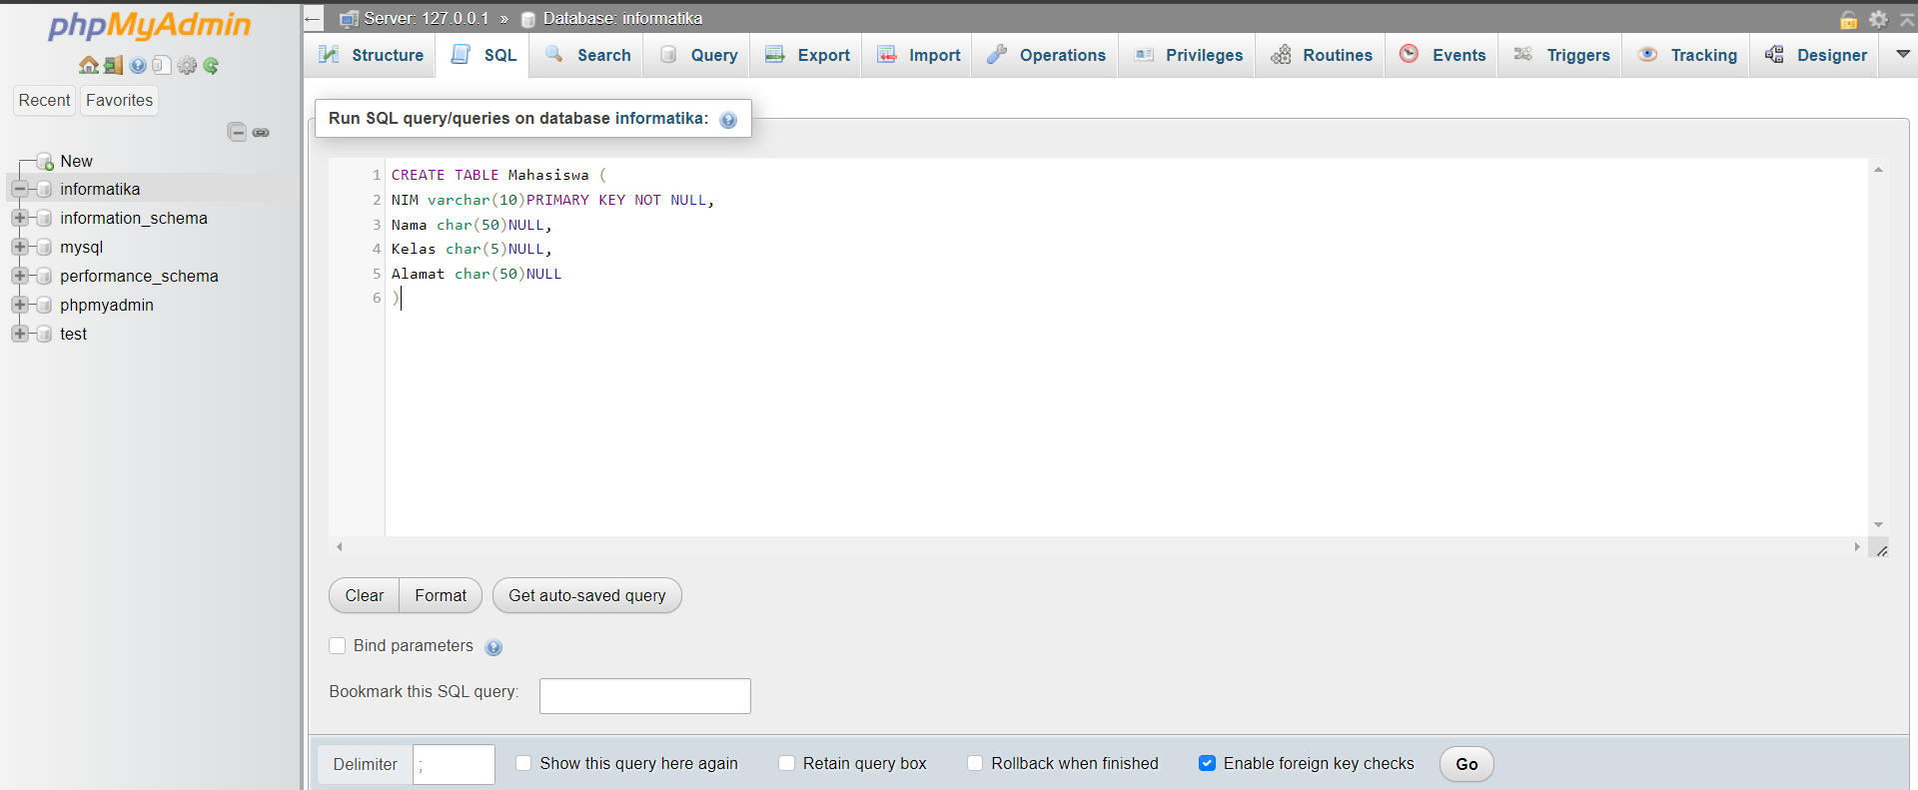

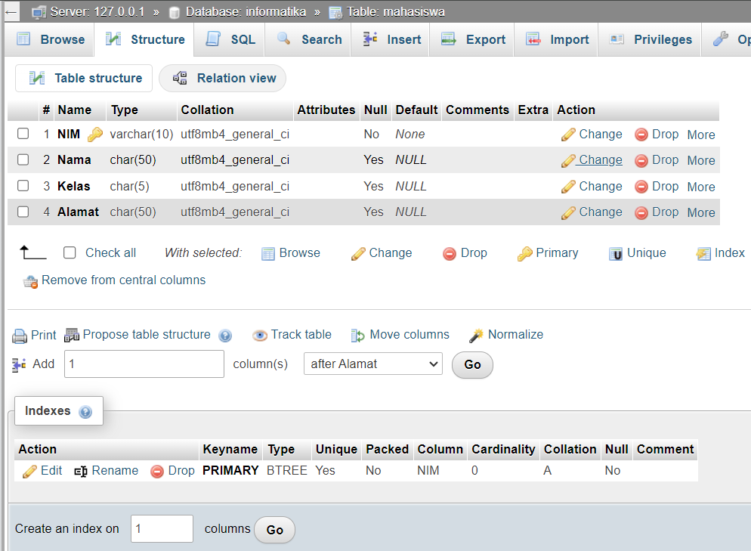

1. **Experiment 3 (Insert Data)**

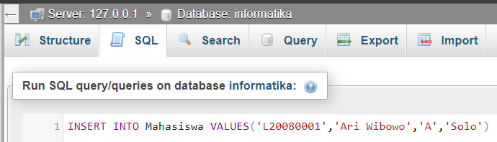

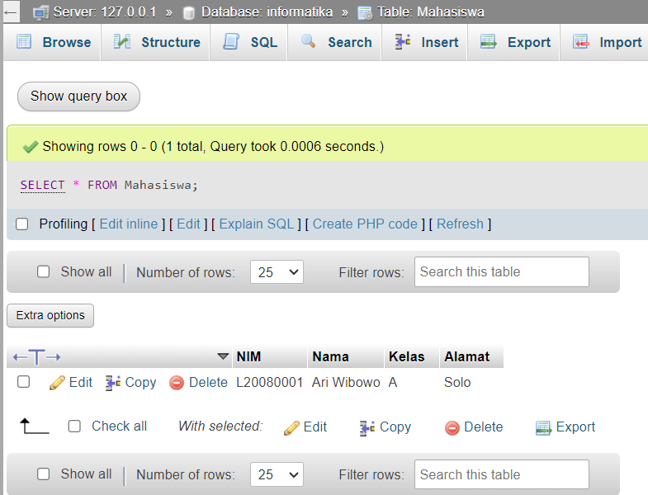

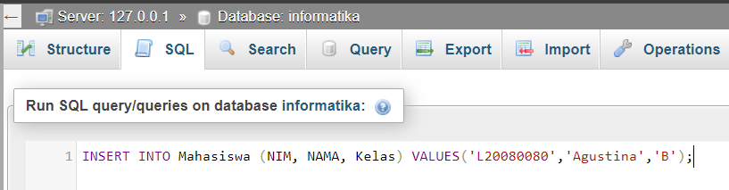

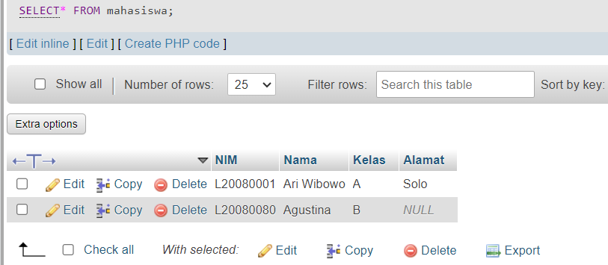

1. **Experiment 4 (Changing Data)**

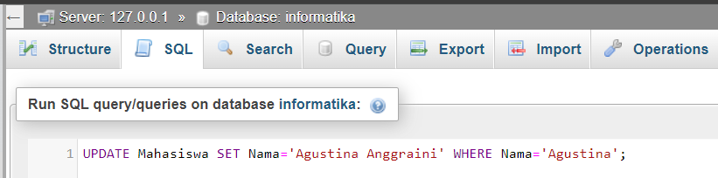

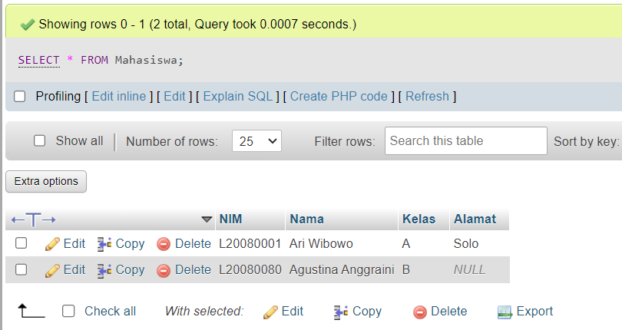

1. **Experiment 5 (Join)**
2. Table Nilai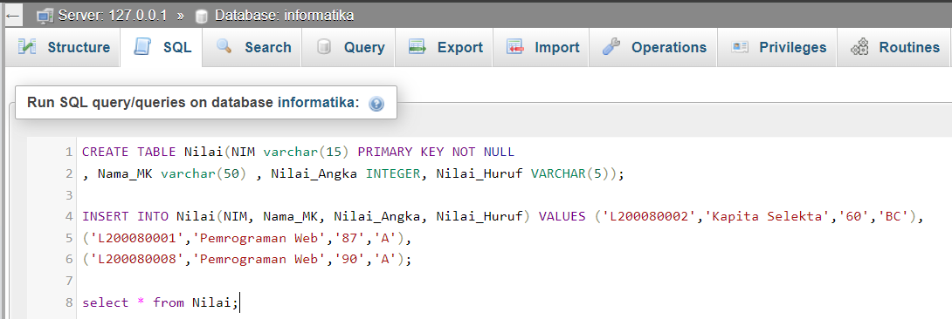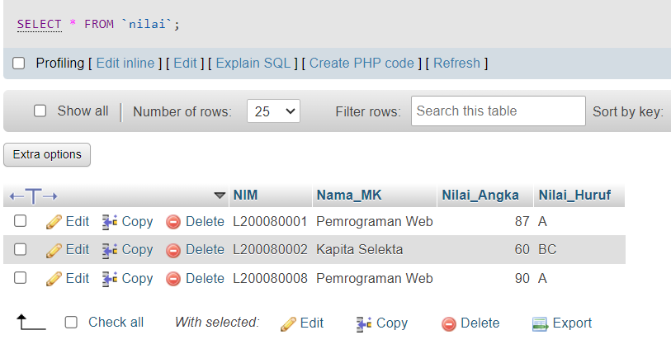
3. Experiment

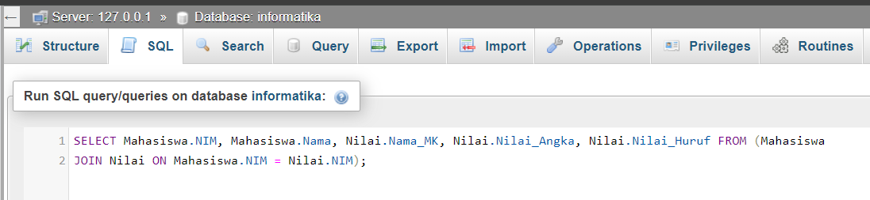

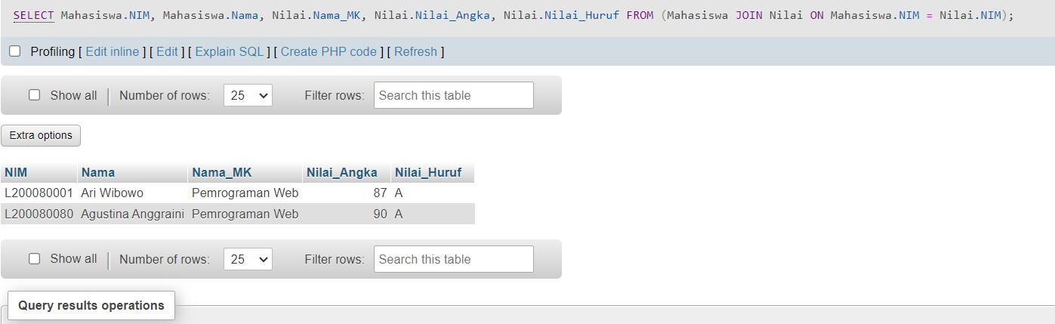

1. **Experiment 6 (Left Join)**

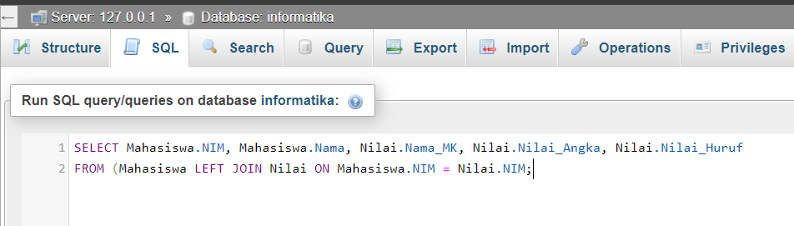

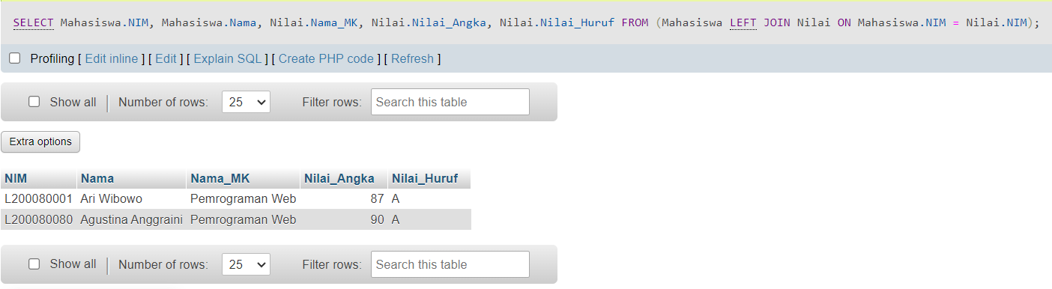

1. **Experiment 7 (Right Join)**

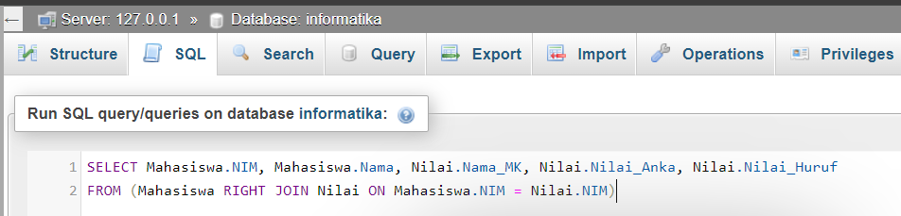

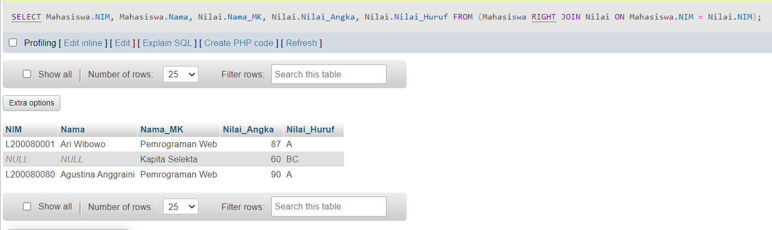

1. **Experiment 8 (AVG Function)**
2. **Experiment 9 (SUM Function)**
3. **Experiment 10 (View)**

**ASSIGNMENT**

1. **Addition of**